Overview
The PO Expedite report displays the prioritizing information for all outstanding MDV purchase orders including estimated outs, pending advanced sales orders, and other relevant data. The report has the ability to filter the results by Buyer, Warehouse, Vendor, and several other factors. Additionally, a user can easily drill down to the Purchase Order Line and Item Details or extract the information as an Excel download.
This document has been prepared for the release of the PO Expedite page of the MDV website. The PO Expedite report is available on the main menu of the MDVNF.com website after logging in, and is only viewable by internal users.
Report Types
There are two versions (report types) of the PO Expedite report: the Default and the Arrived.
Default
The Default report type is the view used to review open purchase orders and identify opportunities among them.
Arrived
The Arrived report type is primarily used by the operations staff in Norfolk to prioritize purchase orders which have already arrived.
Default Report Type
PO Expedite Summary View
This is the initial view when running the Default report type. At this level, all PO’s that match the current filters are displayed on the page. Each line will show basic information that pertains to a PO such as dates, the vendor information, the estimated cuts of the entire PO, etc.
Note: if a PO has arrived and has not been received for more than 3 days, the Arrival Date will be highlighted red.
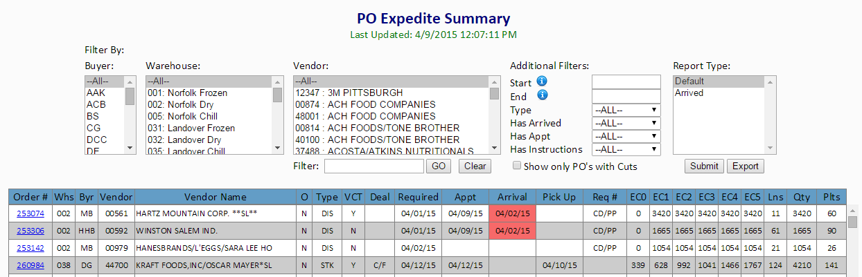

PO Expedite Details View
This view is accessed by clicking on a PO number from the PO Expedite Summary View and is displayed in a new tab. At this level, the PO header information and line details (including estimated outs) will be displayed. Hovering over some of the column headers will display a tool-tip describing the field contents.
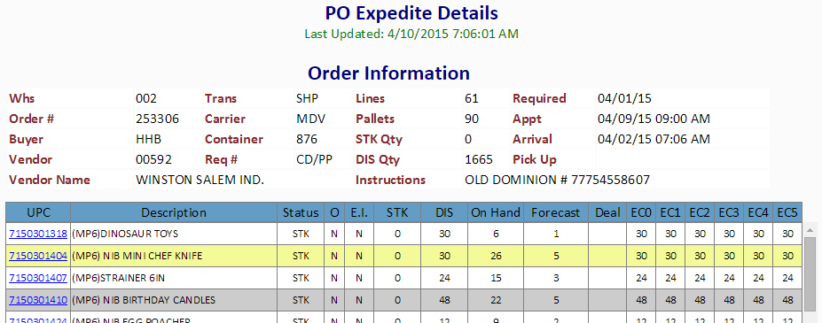
Line Details View
To access this view, click on any UPC from the PO Lines View. The view display will be populated by three new tables if the corresponding data exists. The three tables display pending purchase orders, pending advanced sales orders, and deals for that item. All current and future deals are displayed on this view if they are ending more than 1 week out and whose start date is no more than 2 weeks from the current day. Clicking the hyperlink on the UPC in this view will display the Product Inquiry page for that item in a new tab.
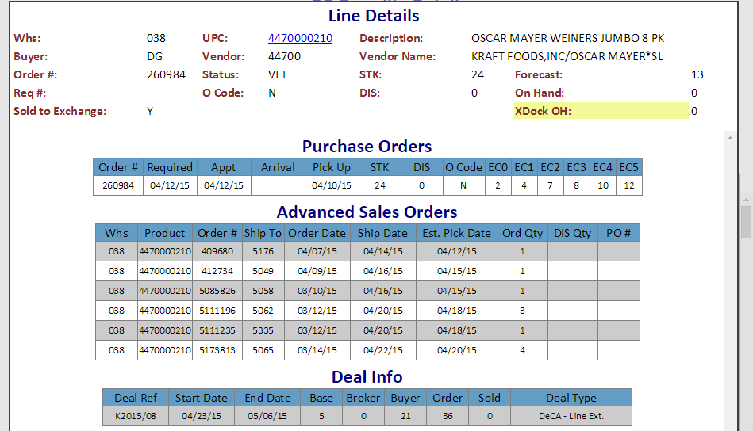
How to generate the Default report
- Log in with your normal website credentials.
- Click the PO Expedite Link in the Purchase Orders menu panel.
- If not already selected, select the Default report type.
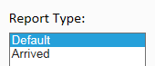
- Select any criteria you would like to filter the report by (such as buyer, warehouse, and/or vendor).
  - Each filter option defaults to “—All—”.
  - The vendor list can be further filtered by typing a vendor number or part of a vendor name and clicking “GO”. The desired vendor(s) will need to be selected in the resulting list.
  - The additional options allow the PO Summary List to be filtered based on the following:
    - Start Date – Any PO with an RDD, Appt, or Arrival Date on or after the selected date
    - End Date – Any PO with an RDD, Appt, or Arrival Date on or before the selected date
    - Type – All POs of the selected type options (i.e. STK, DIS)
    - Has Arrived – All POs which have a recorded arrival date
    - Has Appt – All POs which have an appointment date
    - Has Instructions – All POs which have instructions
    - Show only POs with cuts – Only show POs with expected cuts by day 5
- Click the Submit button to generate the report based on the selected filters.
  - The PO Summary will be displayed below.
- If desired, click any PO number to generate the PO Expedite Details View.
  - The PO Lines view will be displayed as a new tab.
  - Click Close to return to the PO Expedite Summary view.
- In the PO Expedite Details view, click on any UPC to generate the Line Details view.
  - The Line Details view will be displayed as a popup window.
  - Clicking the UPC in the Lines Detail view will open the Product Inquiry page for that item in a new tab.
  - Click Close to return to the PO Expedite Details view.
- To export the search results to an Excel output click on the “Export” button.

Arrived Report Type
PO Expedite Summary View
This view is primarily used by Norfolk operations to manage arrived purchase orders. The purchase orders are grouped and highlighted by trailer number and sorted in order of total expected cuts (1 day out) for each trailer. The expected cuts calculation is the same as it is in the Default report type.
The arrived view displays additional information: Carrier Name, Trailer number, and Trailer Priority in the website view and Route code in the Excel export.
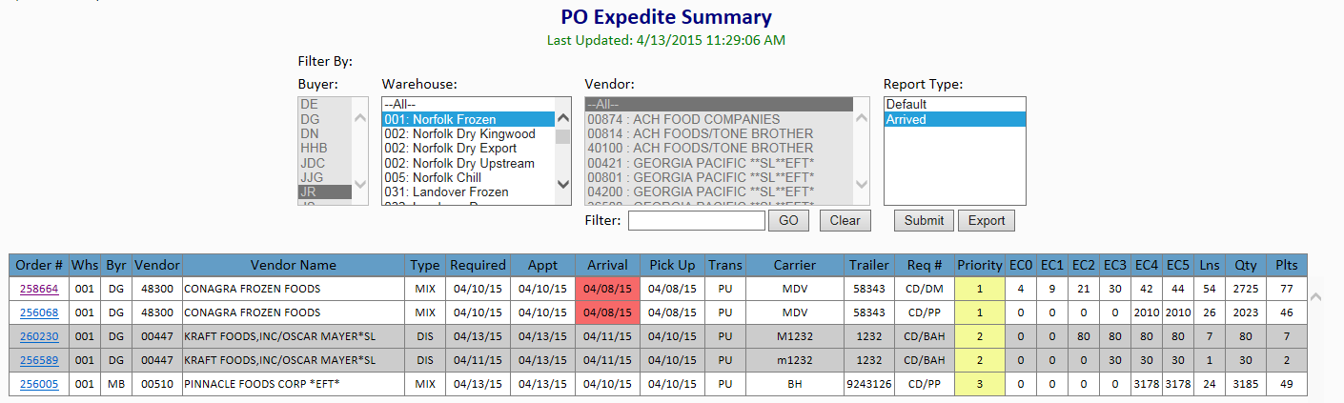
How to generate the Arrived report
- Log in with your normal website credentials.
- Click the PO Expedite Link in the Purchase Orders menu panel.
- Click on the Arrived report type in the PO Expedite Summary options
  - The filter options will automatically change, so only the warehouse filter may be used.
- If desired, select a warehouse to filter by.
  - If multiple warehouses are selected, the results can only be viewed in the Excel export.
- Click the Submit button.
- The PO Expedite Details and Line Details views operate the same as in the Default report type.
- In the Excel output, the POs are listed by priority, separated into different tabs by warehouse.
  - Norfolk Dry POs are separated by Kingwood Dry, Village Export, and Village Upstream.

Calculations
The expected cuts calculation is performed differently based on the purchase order type (e.g. STK, DIS, or MIX).
Distributed POs
For distributed purchase orders, the expected cuts will correspond to the distributed quantities on the purchase orders, and will be attributed to the day in which those sales order quantities should be picked from the warehouse. For Germersheim and Kaiserslautern, the estimated pick date will be the Friday before the ship date. For Gitmo the estimated pick date will be 2 days before the ship date, and for Ft Buchanan the estimated pick date will be 7 days prior to the ship date.
Stock POs
For stock purchase orders, the expected cuts calculation is based on four things: on hand quantity, daily item forecast, alternate incoming stock purchase orders, and advanced sales orders.
To estimate a daily item forecast, the system forecast is multiplied by the percentage of sales that occur on that day of the week (i.e. Monday, Tuesday …). The weekday percentage of sales is calculated for each department by reviewing the department sales over the past 52 weeks.
Alternate incoming purchase orders will reduce the expected cuts by the assumption of replenishing stock once received. The incoming PO quantities will become available based on the average number of days that the warehouse receives POs. Only the quantities which are not distributed will become available.
Advanced sales orders will affect the expected cuts calculation for stock purchase orders by attributing those sales order quantities to the estimate pick date as designated by warehouse picking rules. Advanced sales orders are defined as any order whose order date and ship date differ by 5 days or more.
The expected cuts calculation evaluates the expected inventory of each day by estimating a running inventory total based on the on-hand quantity, daily item forecast, pending advanced sales orders, and alternate incoming purchase orders. If the estimate results in negative inventory, that negative inventory represents the expected cuts for that day.
The expected cuts by day are displayed as a cumulative sum in the EC columns on the report output to relay the overall impact of not receiving that purchase order.
Mixed POs
The expected cuts for mixed purchase orders will be calculated as if they were stock POs in addition to the distributed quantities being cut on the respective pick dates.
Reading the Tables and table functions
For each table, most columns should be self-explanatory, such as Vendor Name or Arrival Date. The columns that are not self-explanatory however have tooltips to explain what the column is. To access these tooltips, hover the mouse cursor over the column header for at least a second and the tooltip will be displayed.
Each table is automatically sorted by EC3 (estimated cuts day 3) in descending order. To sort any table by a different column, simply click the column header. Doing so will sort the table by the selected column in descending order. Click again to sort in ascending order. Please note that the columns in the Arrived report type cannot be resorted.
The PO Expedite data is generated twice a day. The first run should complete around 7:10 am, and the second run should complete around 11:30 am. This information will be reflected on the page below the title (PO Expedite Summary) as well as the tooltip for the menu icon. It is important to note that during the load process, incomplete data will be available. Please verify the “Last Updated” timestamp under the title when accessing the report during these timeframes.
Help/Troubleshooting
Below is a list of possible issues that may come up when working the PO Expedite report followed by an explanation and/or troubleshooting steps
PO appears multiple times on the PO Summary
In the PO Expedite Report, PO’s are assigned by the buyer that is tied to the item record. So, if multiple buyers have items on a single PO, then that PO will be appear multiple times on the report, split out by buyer.
Report doesn’t display results
Try the following:
- Make sure the www.mdvnf.com website is not being displayed in compatibility mode
  - Under Tools Compatibility View settings
    - If the Tools menu is not visible, hit F10
- Make sure that the checkbox for viewing all web pages in compatibility mode is unchecked
  - Under Tools Compatibility View settings
- Make sure the Internet Explorer Text size is set to Medium
  - Under View Text size
- Try closing your web browser and re-opening the report
Column headers are not lined up properly
Try the same steps list above for “Report doesn’t display results”
Download limit error message
If you get a message when exporting to Excel that you’ve hit a download limit or the report results are too large to download, then there is too much information to export into Excel. Please add some filters to your search such as buyer(s) or warehouse(s) and try again.
Anything else:
If you experience any other issues, try closing your web browser and re-opening the report. If the issues continue, please log a problem ticket with Computer Support Center (CSC).

